**Water Pie**

This Depression-era recipe still holds up, especially if you're looking to bake a simple, thrifty dessert.

By **Sarra Sedghi**

June 07, 2021

When it comes to baking, those classic recipes that existed long before you (or even your parents) were born always seem to circle back. This is especially true with Depression-era recipes like wacky cake and peanut butter bread, which are both inexpensive and easy - and not to mention delicious.

If you're really looking for a recipe that costs pennies to make and seemingly alchemizes out of nothing, however, you need to try water pie.

**What Is Water Pie?**

Water pie is a sweet pie made with just six ingredients: water, flour, sugar, vanilla extract, butter, and a pie crust.

Making a pie that requires a mere six ingredients may seem like a fun hack today, but during the Great Depression, water pie was simply a dessert that reflected the circumstances for many Americans. Since water pie doesn't require milk or eggs, it allowed people going through hard times to enjoy something sweet without using up valuable and expensive ingredients.

Like other recipes that originated during the Great Depression, water pie stretches a handful of ingredients by turning them into something substantial. These dishes were one of the few foods you could make with limited resources you had. Water pie managed to stick around after the Depression ended, thanks to its low cost and simplicity - a little nostalgia never hurts, either.



CREDIT: LINDSEY HAYES

**What Does Water Pie Taste Like?**

Water pie's flavor profile is best described as simply sweet. Since it doesn't contain a large amount of ingredients, it isn't overbearing or excessively saccharine.

Water pie has a gelatinous texture, so the filling resembles what you'd find in a chess pie. You can switch up your water pie's flavor by using a different-flavored extract, such as lemon, almond, or coconut, or replacing it with apple cider vinegar for a slight apple pie-like taste. You could also use Sprite instead of water.

**How to Make Water Pie**

To make water pie, you'll need six ingredients:

* 1 1/2 cups water
* 1/4 cup flour
* 1 cup sugar
* 2 tsp. vanilla extract
* 5 tbsp. butter, divided into pats
* A pie crust, either store-bought or homemade

**Step 1: Preheat oven.**

Preheat your oven to 400 degrees F (or 204 degrees C).

**Step 2: Prepare your pie crust.**

If you're using a store-bought pie crust, roll it into a regular nine-inch pie plate. Crimp or trim the edges of excess dough.

If you're making a pie crust, follow directions of the recipe. Then, roll the crust into a nine-inch pie plate. Crimp or trim the edges.

**Step 3: Add water.**

Pour the water into the pie crust.

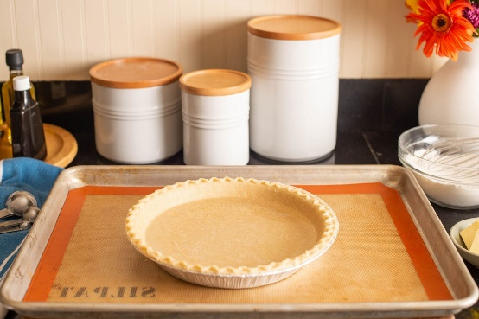

CREDIT: LINDSEY HAYES

**Step 4: Add flour and sugar.**

In a separate bowl, combine the flour and sugar. Whisk until well mixed. Sprinkle flour mixture into the water. Do not stir.

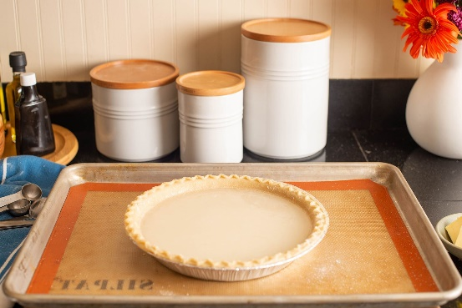

CREDIT: LINDSEY HAYES

**Step 5: Add vanilla and butter.**

Drizzle the vanilla extract into the pie. Place the pats of butter at the top of the mixture so they float.

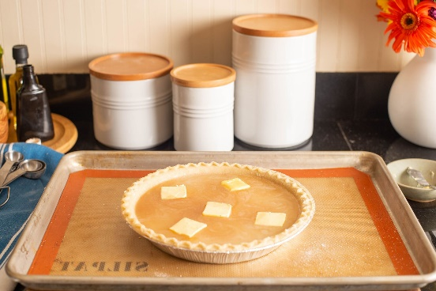

CREDIT: LINDSEY HAYES

**Step 6: Bake the pie.**

Bake at 400 degrees F for 30 minutes. Then reduce the heat to 375 degrees F (190 degrees C) for 25-30 minutes. Remove from oven and let cool.

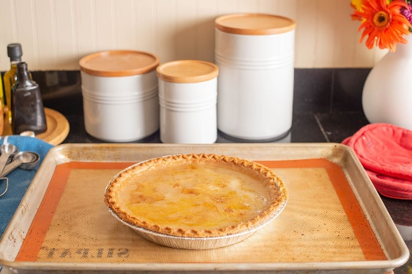

CREDIT: LINDSEY HAYES

https://www.allrecipes.com/article/what-is-water-pie/?utm_medium=browser&utm_source=allrecipes.com&utm_content=20210619&utm_campaign=1097894